W300A-How to setup the AP mode?

Product line: Wireless Question category: Function configuration

Q: When do we need to configure AP mode for W300A?
A：Sometimes we have one wired router, and we want to access the Internet wirelessly on laptop, the AP mode of W300A can help you to achieve it.
The topology is as below
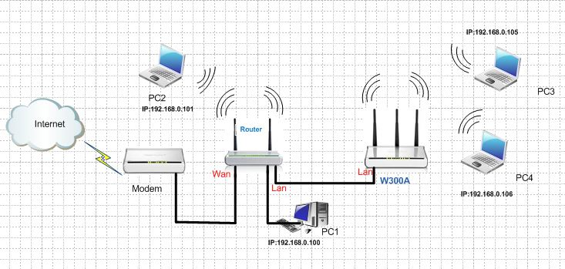
The steps are as below:
1. Login to the homepage of W300A
2. After login successfully, the following page will appear. Please click on Next.
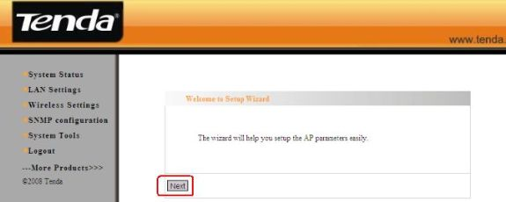
3. Please choose AP as working Mode, change Main SSID (the name for your wireless network)and then choose Channel 6. Please choose WPA-PSK as Security Mode and choose AES as the WPA Algorithms. Then please type the password for wireless network in the blank of passphrase (only 8-10 characters). Then click Apply to save the configurations.
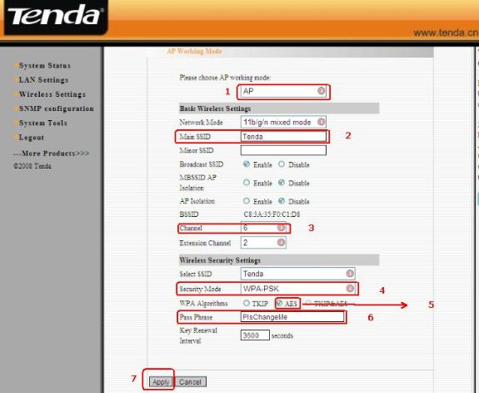

4. Please click Wireless Setting→WPS Settings to disable the WPS.
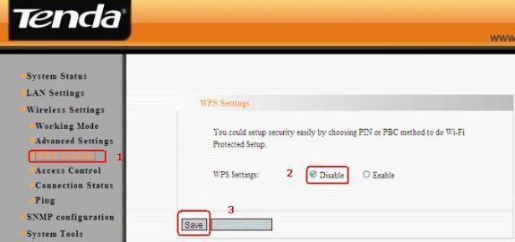
5. After we finished the configurations then we should do the connection as the topology above, then the wireless client connect to the W300A will get the ip address from the uplink router, and connect to the Internet through uplink router.

